How to Use the Southwark Individual Support Plan

Individual Sections:

* All About Me – details about the child/young person(CYP)
* Baseline Assessment
* Cycles of Support

General Tips:

* 'Click or tap here to enter text’ - click and enter whatever text you want. *NB: these boxes are limited in size – if this is an issue, delete the text box and type into the space directly.*
* ‘Choose an item’ - click and choose from the given options
* NOTE: full functionality with drop-down menus is not available on Microsoft online – it is only available through the Desktop application

All About Me

* Name, date of birth, date plan started (the date that the assessment/discussion began)
* The CYP’s views should be captured in a way that works for them – this table can be filled with words or pictures.

Baseline Assessment – EYFS and Primary

|  |  |
| --- | --- |
| Transition/Self-Care/Preparation for Adulthood | Any diagnoses  *Choose from the suggested diagnoses or type in others – these must be diagnosed, not a possible diagnosis or awaiting any assessments* |
| *Areas to think about: toileting; dressing; skills with self-care generally; ability to understand risk and keep themselves and others safe; understanding of money; employability skills*  . |
| Cognition and Learning | Communication and Interaction |
| *Bullet Points - Areas to think about:*  *English (reading, writing); Maths; attention and concentration; ability to work with others; engagement; perseverance; independent learning skills* | *Bullet Points - Areas to think about:*  *Receptive language – following instructions, understanding; Expressive language – fluency, clarity, use of grammar in speech; Reciprocal conversation; Speech sounds* |
| Social, Emotional and Mental Health | Physical and Sensory Needs |
| *Bullet Points - Areas to think about:*  *Social skills – turn taking, sharing, making and maintaining friendships, initiating social contact, understanding social ‘rules’, unstructured times; Resilience; Emotional understanding and regulation; Ability to cope with change and transitions* | *Bullet Points - Areas to think about:*  *Visual difficulties; Hearing difficulties; Sensory challenges (sensory seeking, sensory avoidance); Fine motor skills; Gross motor skills; Difficulties with eating (food choices/avoidance etc.* |

Baseline Assessment – Secondary

|  |  |
| --- | --- |
| Preparation for Employment or Further/Higher Education | Any diagnoses  *Choose from the suggested diagnoses or type in others – these must be diagnosed, not a possible diagnosis or awaiting any assessments* |
| *Bullet Points – Areas to think about:*  *Careers understanding/aspirations; core skills – English and Maths; ability to work independently; ability to work in a group with peers; ability to follow instructions; engagement in learning; completion of tasks; organization*  . |
| Friends, Relationships and Community Participation | Health |
| *Bullet Points - Areas to think about:*  *Social skills – turn taking, sharing, making and maintaining friendships, initiating social contact, understanding social ‘rules’;* *Expressive language – fluency, clarity, use of grammar in speech; Reciprocal conversation; Understanding of positive relationships (including sexual)* | *Bullet Points - Areas to think about:*  *Speech sounds; Emotional and mental health – anxiety, coping with change, resilience, asking for/accepting support; Using NHS services; Managing health conditions* |
| Independent Living | Social Care |
| *Bullet Points - Areas to think about:*  *Financial management; Life skills; Ability to navigate their local environment; Transitions; Coping with hearing difficulty or visual difficulty; Use of technology* | *Split into ‘Concerns’ and ‘Support’: this section is specifically about what involvement (if any) social care have (or should have?) with this young person* |

Cycles of Support

|  |  |  |  |  |  |  |
| --- | --- | --- | --- | --- | --- | --- |
| Cycles of Support Cycle 1 From: 1.9.2023 To: 31.12.2023 | | | | | | |
| Area of Need(specialist advice, and current attainment if appropriate) | SMART target | How will this be achieved? | | | | Outcome |
| *Choose areas of need to work on – the overall area of need is likely to be the same for three cycles, with only the SMART targets changing*  *If a CYP has difficulties across multiple SEN areas, there needs to be a target for each (use SALT targets where given)* | Steps towards improving the area of concern  Secondary SENCos – the focus should be on Preparation for Adulthood | (This is your provision map – exactly what will be put into place, how often, when, and in what ratio) | | | | Choose from achieved/partially achieved/not achieved  Add some detail – but remember, there will be a TAC space below where you can talk more widely |
| *Example:*  *(C&L) Writing*  *Y3D (two years below ARE)*  *EP states X needs TA support in text-rich lessons and precision teaching daily.* | *Example:*  *X will be able to use accurate punctuation in her writing, including direct speech, with less than 4 errors per A4 page.* | *TA support in all English lessons* | *Daily* | *1 hour* | *Pair* | *Example:*  *Achieved*  *X engaged well with TA support – she is using a checklist on her table to check her work before seeking help. Teacher notes she is using speech marks accurately.* |
| *Precision Teaching* | *Daily* | *10 minutes* | *Individual* |
| TAC meeting Date Click or tap here to enter text. Attendees: Click or tap here to enter text. | | | | | | |
| Progress  Detail the positives – think about your long-term outcomes; any positive assessments; any areas where enough progress has been made so that they are no longer areas of concern  Ensure you capture parent and CYP views here, as well as teacher/TA/SENCo | | | | | | |
| Areas for development (including any new specialist advice)  New areas of concern; areas which still require support  Ensure you capture parent and CYP views here, as well as teacher/TA/SENCo | | | | | | |

How to use the specific pages (with images)

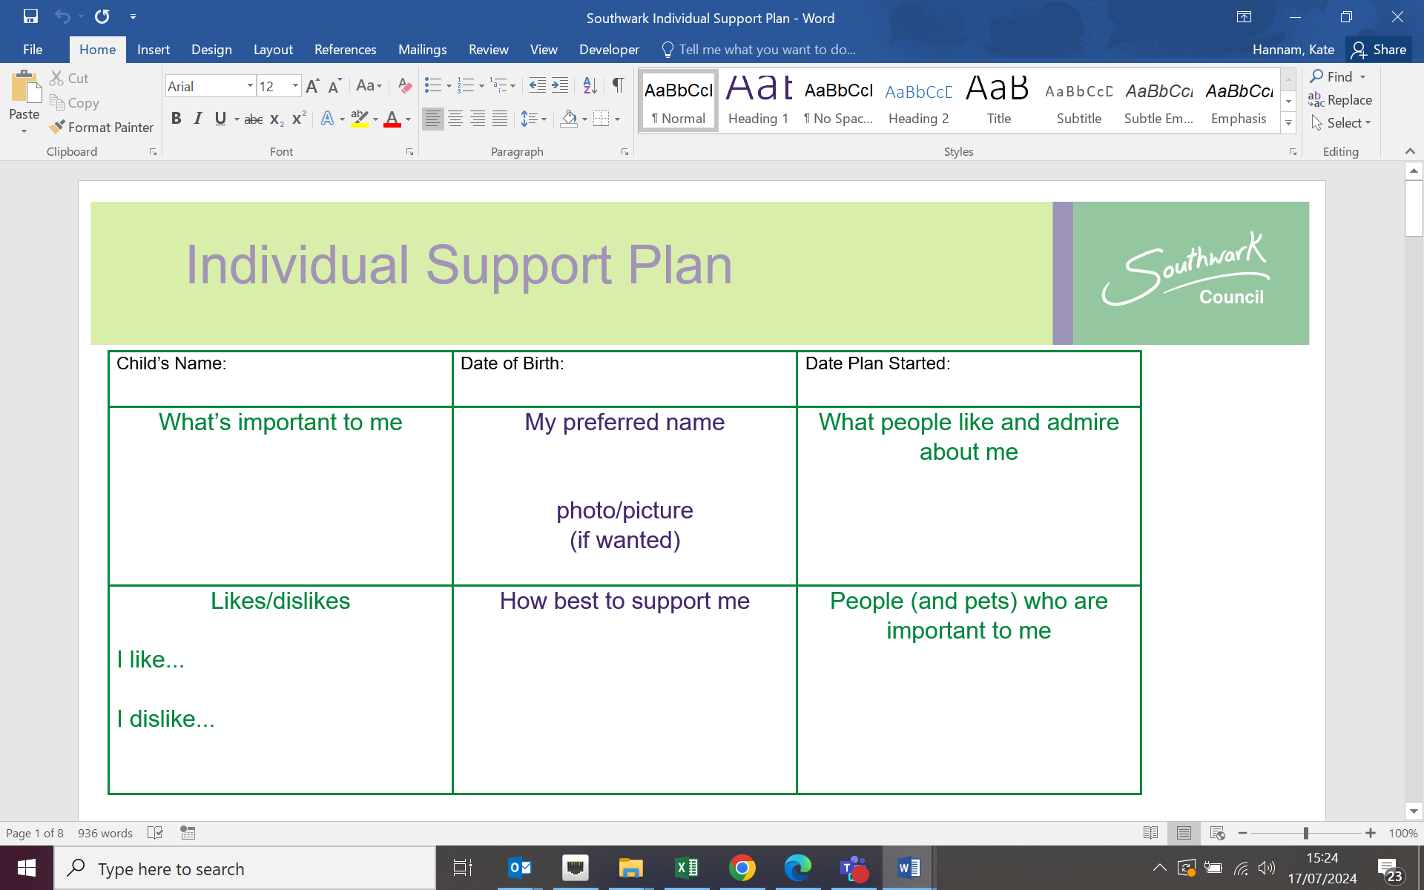

Use this page to detail the child/young person’s views – use pictures or words, as appropriate. If possible, this should be the CYP rather than their parent’s views – think about how to capture that!

Use this box to think about what works – bullet points are best here

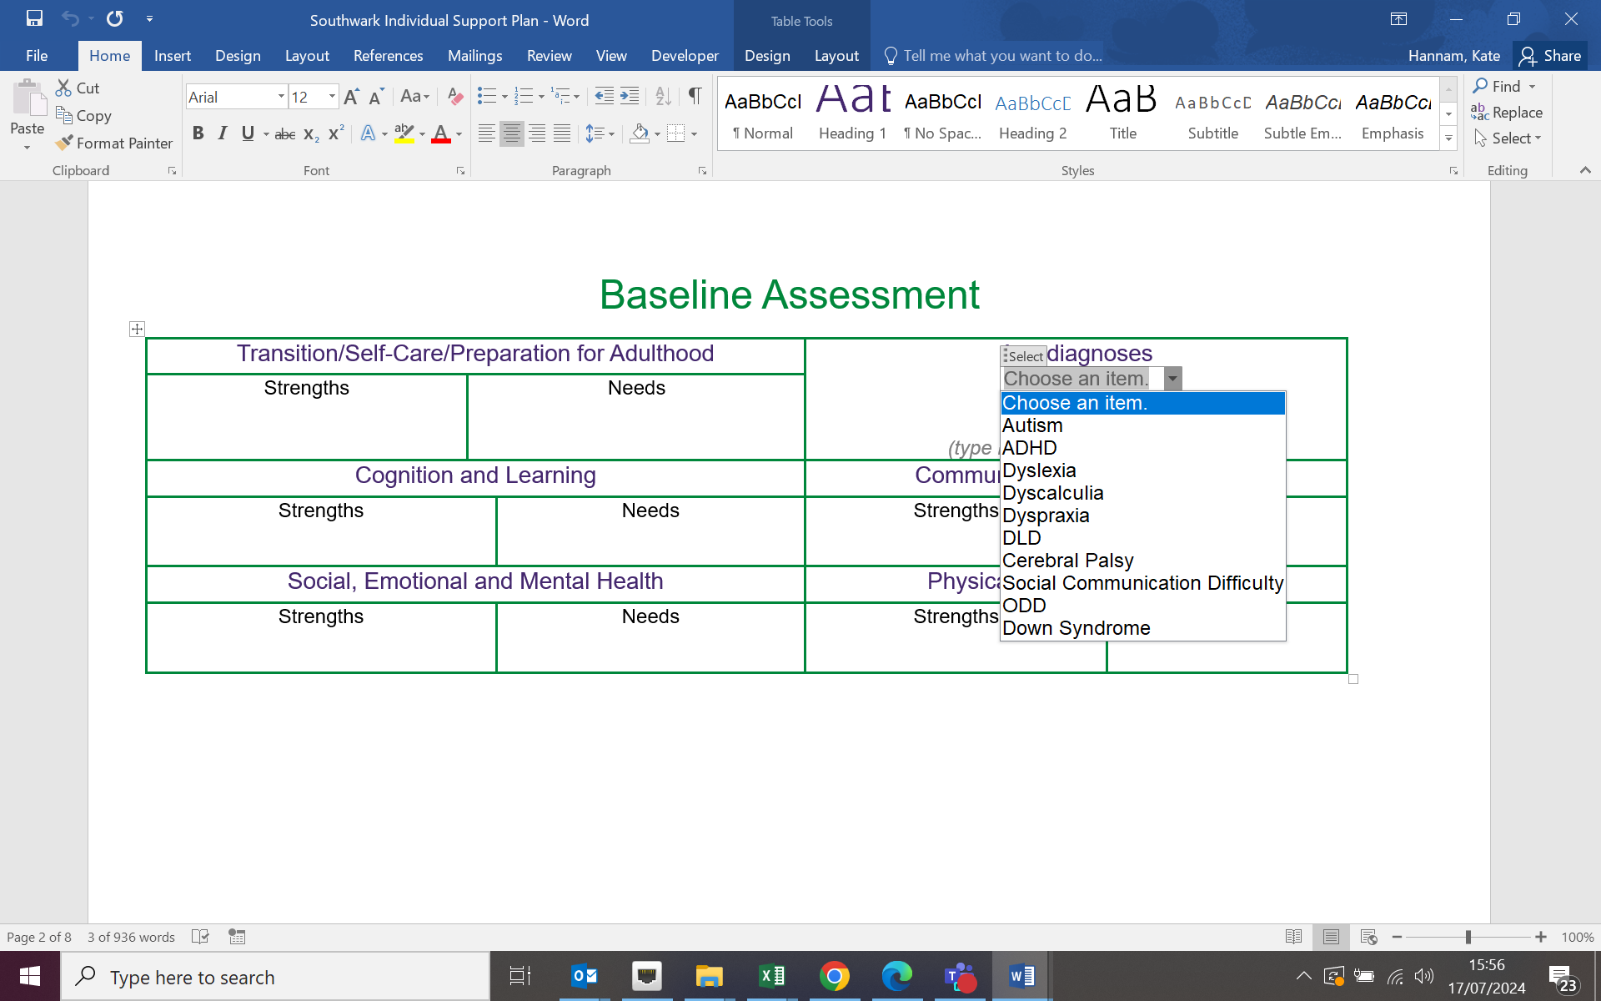

**Transition/self-care/preparation for adulthood**: consider: toileting; dressing; general self-care (at school); understanding of money; understanding of safety and risk; ability to travel independently (as age-appropriate); aspirations and career goals (including any research or study into what is needed for those).

**Strengths and Needs**: use teacher’s views of strengths and needs, as well as any other professional assessment, e.g. SALT, EP

**Physical and Sensory**: includes hearing and visual difficulties, physical difficulties (including fine and gross motor skills), alongside any difficulties with sensory seeking or sensory difficulties.

**Cognition and Learning**: English (reading, writing); Maths; attention and concentration; ability to work with others; engagement; perseverance; independent learning skills

**SEMH**: Social skills – turn taking, sharing, making and maintaining friendships, initiating social contact, understanding social ‘rules’, unstructured times; Resilience; Emotional understanding and regulation; Ability to cope with change and transitions

**Communication and Interaction**: Receptive language – following instructions, understanding; Expressive language – fluency, clarity, use of grammar in speech; Reciprocal conversation; Speech sounds

**Diagnoses**: these can be selected by a drop down menu. If a diagnosis is not on the list, it can be typed below the drop down boxes. NB: These *must* have been diagnosed, not a possible diagnosis or awaiting assessments.

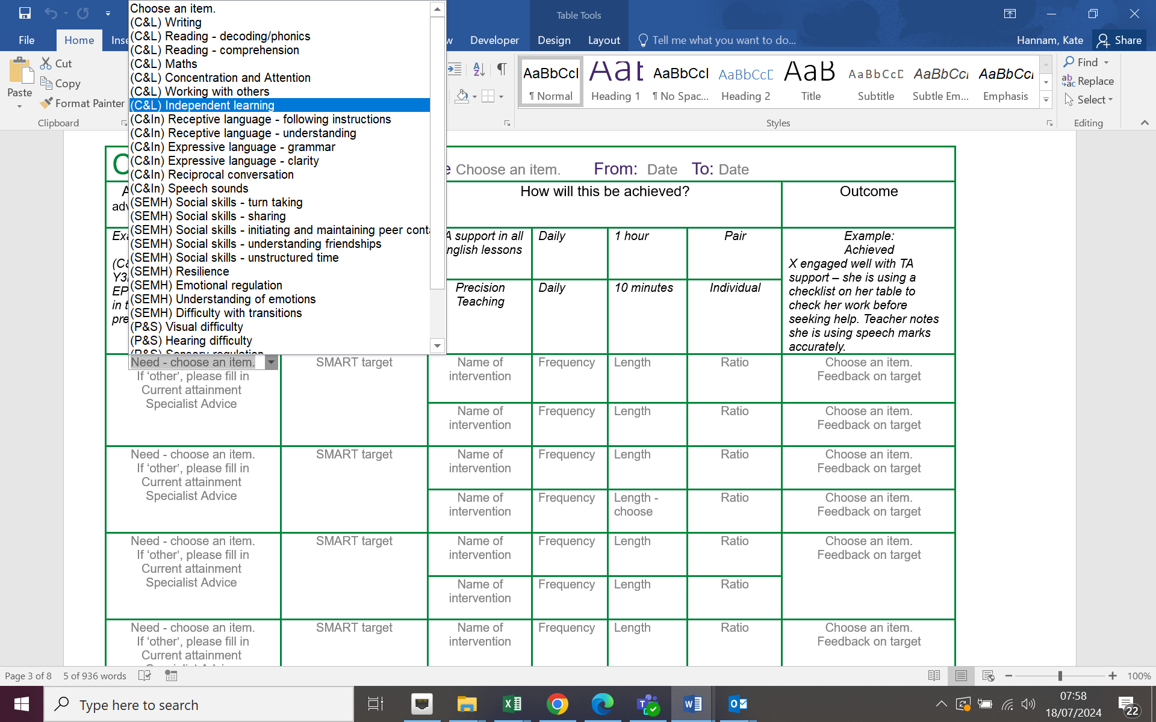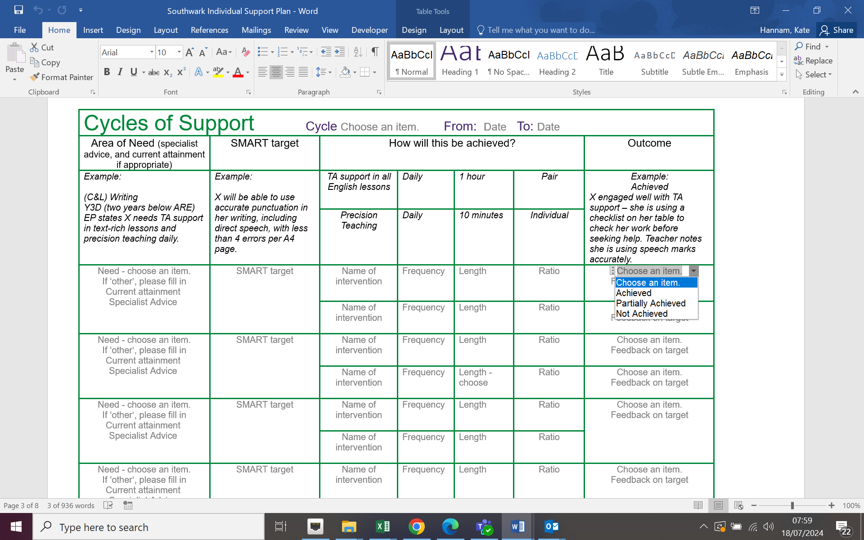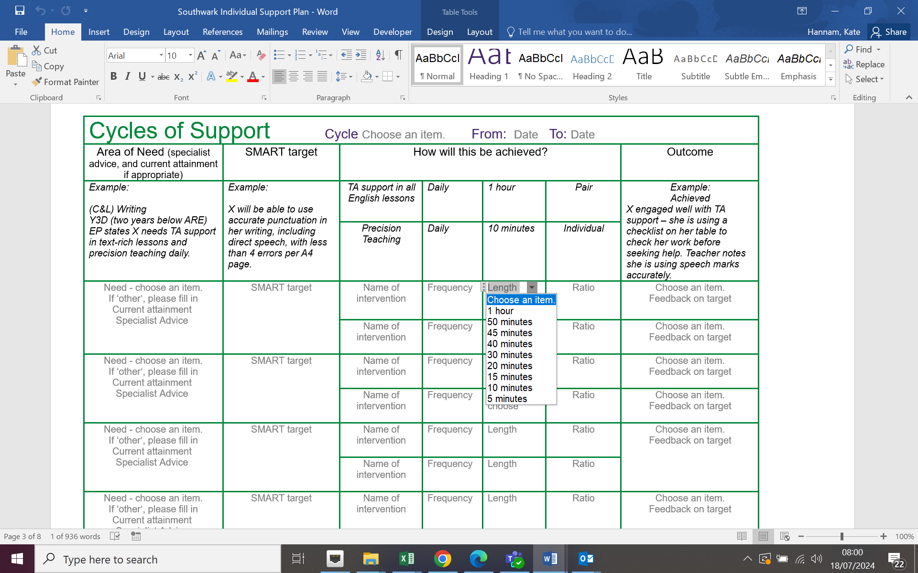

**How will this be achieved?:** Type in the intervention (which should include TA support in a particular lesson). There are dropboxes for frequency, length and ratio. If the intervention does not fit within these options, delete the dropbox and type in.

**Need**: choose from the dropbox if possible – or choose ‘other’ from the dropbox and fill in the option below (If ‘other’, please fill in).

**Current attainment**: use school’s system of attainment as this is an internal school document.

**Specialist advice**: note any specific advice from EP, SALT etc., that has led to this target or intervention

**Outcome**: Choose from the dropbox, then below write teacher’s specific feedback on the target.

**SMART target**: a target for this cycle (usually a term), focussing on the area of need.

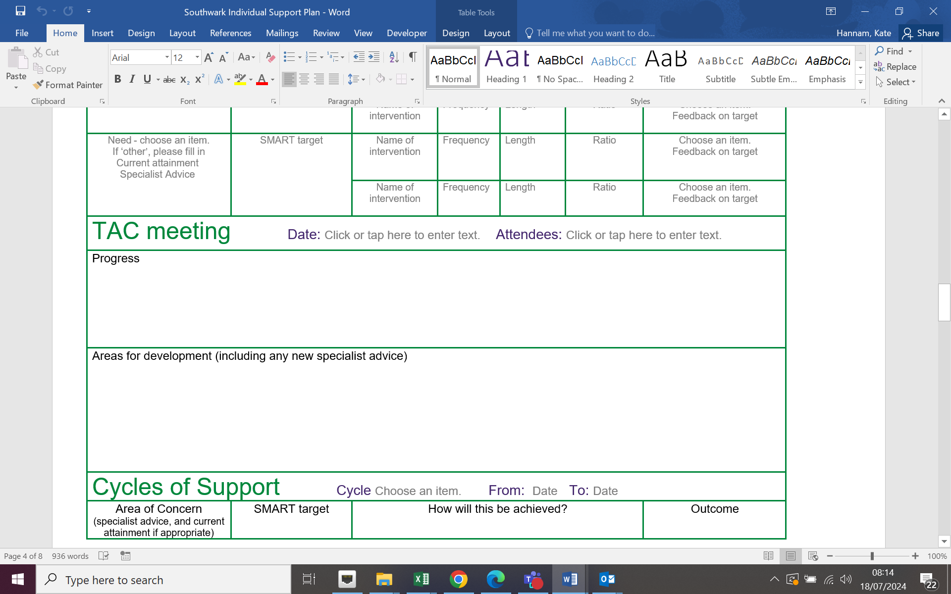

**Progress**: This needs to include the views of everyone in the meeting. You do not need to capture views on the targets, as these are already in the cycles of support.

**Areas for development**: What needs to be worked on in the next term? Bullet point any new specialist advice/assessments.