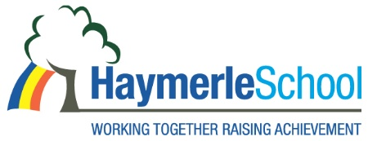
SEN Class Teacher
Salary: Main Scale Inc. ILW + SEN Allowance
Contract: Full Time
Term: Permanent
The headteacher and Governors of Haymerle School are seeking to appoint enthusiastic and committed teacher who is keen to develop their knowledge and skills in working with pupils with autism and associated complex needs.
If you want to work in a successful, diverse and vibrant school, we are looking for someone who:
· is committed to continuous improvement
· is passionate about children’s learning
· can work as part of a team
· is enthusiastic and flexible
· wants to be part of a talented team, in a school which is entering an exciting next phase of its development
Early Career Teachers, Primary/Early Years teachers new to special needs are very welcome to apply, as well as those who have more experience. We can offer you bespoke professional development and support in a caring and positive working environment.
About the School
Haymerle School is a primary Special School for pupils with Autism located in South East London. We support a wide range of learning disabilities including pupils with severe and complex social and communication difficulties. Haymerle School was judged a Good School in our December 2021 OFSTED inspection.
Our recruitment processes follow the guidance in the DfE document Safeguarding Children and Safer Recruitment in Education. All staff will be required to undertake a disclosure from the Disclosure & Barring Service.

The post holder will be expected to carry out all duties in the context of and in compliance with the schools Equal Opportunities Policies.
Appointments will be made subject to satisfactory references.
Please contact the School Office for an application pack on 020 7639 6080 or download the forms on www.haymerle.southwark.sch.uk or on the TES website.
We very much welcome visits to the school by prospective candidates. Please call the school reception on 0207 6396080 to arrange a visit
Please note that we will only accept the Southwark Application forms (downloadable below or from our website: www.haymerle.southwark.sch.uk) and completed applications emailed to reception@haymerle.southwark.sch.uk
Closing date for applications: 14th May 2026
Interviews will be held on: Tuesday 19th May 2026
Post Start: 1st September 2026

