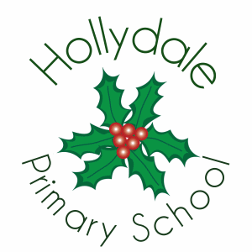

Full Time Class Teacher for
Early Years and Foundation Stage

Salary: Inner London MPS
Contract Term: Fixed Term /Permanent

Early Career Teachers Welcome

This is a superb opportunity for a dynamic and Early Career Teacher who is passionate about children’s learning, committed to creativity and keen to support the Head Teacher in providing opportunities which will raise standards and improve outcomes for the children, staff and community of Hollydale Primary.

We offer:
- A caring and supportive whole school community, culturally diverse and inclusive
- Experienced and dedicated staff committed to achieving high standards
- A supportive, warm and welcoming ethos
- Happy, enthusiastic pupils who are keen to learn
- Excellent support within your phase for planning and assessment
- A calm, friendly, positive, caring and happy school environment
- An ambitious and energetic leadership team
- Governors who are committed to the well-being of all staff
- Small classes and effective additional adult support
- Effective provision for pupils with special and complex needs

The successful candidate will need to:
- Fully qualified teacher status to undertake all Class Teacher duties
- The candidate will be an outstanding practitioner with the ability to inspire and motivate and support pupils, staff and the wider community
- Have a commitment to promote and develop the inclusive ethos and values of the school
- Have a high level of emotional intelligence and excellent communication skills
- Experienced teachers with a minimum of two years teaching is preferred, although outstanding ECTs are welcome to apply.

Benefits scheme includes:
Interest free season ticket loans
- Easy transport links
- Cycle Scheme

You will be central to our aspiration to become an outstanding school

Please visit our website at www.hollydale.southwark.sch.uk for information about our school.

We warmly welcome visits to the school by prospective candidates. To arrange a visit please contact the School Office on 0207 639 2562.

Please download forms and information packs from the Southwark website.

Completed forms must be sent to admin@hollydaleprimary.co.uk

Closing date for applications | Friday 5th June 2026

Please note: Hollydale Primary School is committed to safeguarding and promoting the welfare of children and young people and we expect all staff and volunteers to share this commitment. All posts are subject to pre-employment checks. References will be sought and successful candidates will need to undertake an enhanced Disclosure and Barring Service check.

