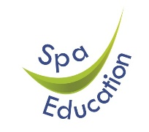

We are looking to appoint
Teaching Assistants
Spa School Bermondsey is a secondary special school for autistic children aged 11-19.
Spa School Camberwell is a new special school for autistic children aged 5 – 16.
We are looking for skilled people to work with our students for both schools.
Applicants must:

- have a desire to work in the field of special education
- are enthusiastic and energetic
- can work to agreed programmes and be consistent

This post is term time only, Hay Scale 5. Annual salary £31,530 (Pro Rata salary £25,545) 33.75 hours per week

Applicants must complete a Spa Education Trust application form which can be downloaded from our website https://spa-education.org/spa-education-trust/vacancies

Completed application forms can be submitted by e-mail to recruitment@spa-education.org

Closing date: Monday 1st June 2026
Shortlisted candidates will be contacted by Friday 5th June 2026

Our recruitment processes follow the guidance in the DfE document Safeguarding Children and Safer Recruitment in Education. All staff will be required to undertake a disclosure from the Disclosure & Barring Service.

