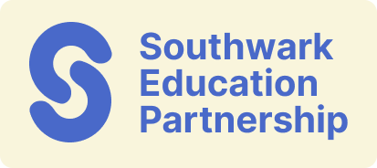
School Inclusion Hub
Annual Delivery Planning Tool

Essential information

Setting Name
DfE Number
Hub Lead name
Hub Lead contact details

Objective What outcome do you want to achieve and how does it align with Southwark’s local SEND and inclusion plan? | Actions  What activities will you deliver to achieve your objective, in line with the hubs delivery themes? | Audience  Who do you attend to be the main audience for this activity/action? | Lead  Who will deliver this action? Will it be commissioned or delivered in-house? | Frequency  How many times per academic year will this action be delivered? | Cost  of Activity (max £30k annual spend) | Impact  What is the intended impact this outcome will have for education settings/Southwark CYP?

Objective (taken from above) | How will you measure progress towards this?
Impact (taken from above) | How will you measure this?

Total funding | £?

