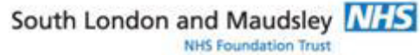
The Hope Project at Southwark CAMHS
Working with Trauma
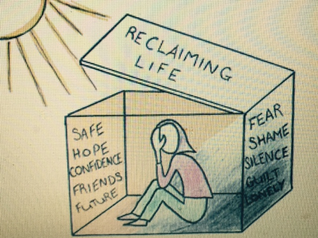
Training For Practitioners in Southwark
Tuesday 17th November 2026, 9.30 – 16.30
Southwark CAMHS, First Floor Mapother House, De Crespigny Park, SE5 8AZ
Children and young people affected by traumatic events may present with a range of difficulties in different settings. The aim of this short course offered by the Hope Project is to increase knowledge and skills in the wider practitioner group in Southwark in relation to:
- Understanding how trauma can affect children, young people and families
- Talking about trauma in a sensitive way
- Recognising symptoms of traumatic stress
- Working with parents and families on providing physical and emotional safety
- Providing psychoeducation on trauma
- Sharing helpful coping strategies with children and young people
The Hope Project offers trauma-focused interventions for children and young people in Southwark affected by trauma. It also offers consultation and training for local practitioners.
Course trainers are from the Hope Project: Dr Camilla Cookson, Clinical Psychologist and Clinical Lead; Francesca Lada, CBT Therapist/Clinical Specialist & Dr Emily Carter, Clinical Psychologist.
There are twenty-five places for this course. There is no fee for the course, but agencies will be charged for non-attendance.

BOOKING FORM

Working with Trauma: A Short Course for Practitioners in Southwark

Please complete and return by e-mail to both:
Camilla Cookson Camilla.cookson@slam.nhs.uk and Francesca Lada Francesca.lada@slam.nhs.uk

Name: ……………………………………………………………………………………………………………………………………….…

Job Title: ……………………..……………….…….…….……………….…….…….…….…….…….…….….….…….…...............

Agency/Organisation: ..………………………………………..……………………..………………………………….………..……

Telephone number: ………….…………...…………. Mobile number:………………………………………………….

Email: ...…………………………..….…………..………………………………………………………………………………………..

Name of Manager: ………………………………………………. Manager’s Signature: ……………………………………….

Date: ………………

There is no fee for the course but agencies will be charged £50 for non-attendance.
Early application is advised: Confirmation will be sent via email to all participants. If you have not received confirmation at least one week before the course start date, please contact Francesa Lada or Camilla Cookson. Do not turn up on the day without having received confirmation. Priority will be given to ensuring a spread of participants from agencies across Southwark.
Data Protection Act: by signing this application, I agree to SLaM keeping data about me for the administration of training courses and conferences. All data held by SLaM is not revealed to any individual or organization other than that required by statute.

