Southwark Governors’ Association
Report of meeting on Thursday 25th June 2020
Martin Deutz Chair, opened the meeting and welcomed everyone to the first ever SGA meeting by Zoom.
Supporting schools and educational establishments during Covid19
Nina Dohel – Director of Education
Nina offered a huge thank you to governors and headteachers for the enormous effort they had made to continue to keep schools open and the support they had given to children in Southwark. Cllr Peter John (Leader of the Council), Cllr Jasmine Ali (Lead member for children and young people) and David Quirke-Thornton (Director of Children’s and Adults’ Services) had all expressed their thanks and admiration for the work which schools are doing.
Regular updates have gone out to Headteachers and Chairs of Governors to keep them up to date with what the Council has done.
In times of trouble people tend to turn to schools for help. 75% of schools have been open and 50 to 60% have been welcoming children from the start of the crisis. The number of children who want to return is growing and the need for distancing is causing challenges for schools.
If this eases it will be easier and the hope is that schools will reopen in September and will not have social distancing. Public health has been very helpful. A webinar was run for schools and governors were invited too. Nina reiterated her thanks to schools for keeping children learning. There has been variation but she believed that schools have done as much as they can in the circumstances.
Work is ongoing on the risks for the black and minority ethnic population. Schools have been risk assessing and need to ensure that policies are in place to provide a safe environment for pupils and for staff. Governors were urged to consider their risk assessments and also to look at the policies they have to ensure they are fit for purpose.
The Head of Governor Services has been asked to provide guidance for governors on looking after their headteacher and supporting their well-being. Those at greatest risk of burnout are Headteacher and Nina is committed to working together to support them. The Health and Wellbeing board have been asked to help but Nina is also looking for direct feedback from head teachers and governors on what specifically is needed to help them
Schools were asked to make sure they kept records of what was being spent to enable them to claim it back when that process is made clear.
There will have to be a focus on how the children will catch up but schools will need a longer term recovery plan to enable the children settle back in and prepare for learning.
Terry Segarty, Assistant Director of Education Standards
Terry expressed his sincere thanks to all school leaders for stepping up and responding to things which could never have been predicted. He and the rest of Standards Team has been working with all of the school leaders in Southwark to be there for schools and meet the challenges. There have been daily conversations with schools to keep abreast of all the information and guidance which had come out
All schools have been open and some of them worked together (eg in Federations) to provide a better service. All of our schools have played their part and some schools offered to be hubs to provide places if they were needed.
The LA has supported schools with sorting out food vouchers and responding to the issues of food poverty.
Education has worked very closely with public health and with other teams in the Council to support vulnerable children and vulnerable families. This has included work with the parking department to enable staff to park for free close to schools.
The next area where school have been supported is carrying out risk assessments and making arrangements to put bubbles in place. Credit is due to school leaders, including governors, for how well this had been managed.
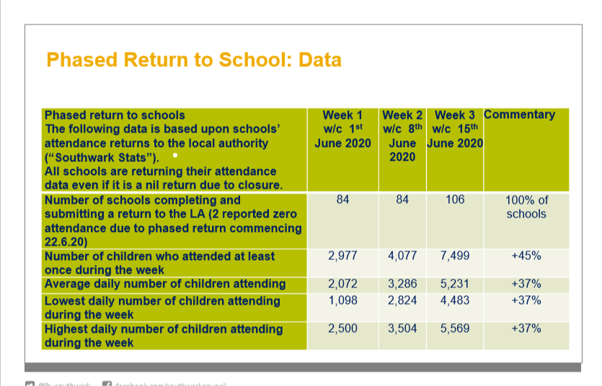
The increase in numbers shows how well this has been managed.
The recovery program which will be needed for schools and pupils will not be a quick fix. Schools will need to supports pupils so that they are ready to learn and prepared to come back. There will be plans in short, medium and long term.
When we have been cheering for the heroes in the NHS Terry felt those cheers were for the heroes in schools as well.
Questions
Will the slides which have been used be available to governors?
The Head of Governor Services confirmed they would be saved onto the website.
Will an equalities impact statement be expected and will there a template?
This is not a requirement and Nina would question why this was necessary. The focus will be on risk assessments and there is no desire to add unnecessary demands on schools. It is therefore highly unlikely there would be a template and risk assessments will cover much of this area. The LA is trying to unpack the information that is being required by the DfE and the purposes for which information is needed.
Data and information presented has been useful but it would be helpful to set the attendance figures in context and to know where schools are the continuum through from those with a small number of children to those with all classes open.
7,500 children attending is a small percentage of the 40,000 children in the borough. Parents currently have a choice and not all year groups are expected to be back. There is a question of capacity for each school. They will already have established bubbles and have had to extend the number of pupils they are admitting. Schools have managed the admission of those children who need to come back. It was hoped this may go up further but in time a plateau will be reached.
It was suggested the comparison should be to compare attendance with the number of children who could be attending.
Has the LA considered measures that will be needed if there’s a second wave?
The Leader of the Council and Chief Executive are working across London on responding to the pandemic and Nina is also working with her peers in other LAs.
Planning is live in case there is a resurgence. It has been shown that Southwark can step up quickly. There will be close working with public health. It is more likely that there would be local spikes leading to lockdown in defined areas.
How will it be justified that social distancing is not needed in schools?
Nina would feel happier if the government would share the research. The return is predicated on the thinking that the youngest children are the least susceptible and in order to allow for a return to work it is important to get primary children back into school. In September the likely plan is to keep children in classes.
What will happen if a child or staff member develops symptoms?
If a school thinks a child has symptoms they should contact public health for guidance.
Are schools expected to stay open during the summer holiday?
There is no expectation from the LA that schools will be open in the summer. Some schools have run holiday play schemes in the past and increasingly this is undertaken by external organizations.
Schools chose to be open at Easter to offer support for their children – they were not asked to do so by the LA.
There has been a range of provision and there has been priority for vulnerable and key worker children.
How schools and governors coped during lockdown and prepared for a wider re-opening.
Bessemer and Keyworth Federation:
Sarah Beard, Executive Headteacher and Karen Azaadi, Vice - Chair of Governors
- Both schools provided childcare / learning for key workers/vulnerable children during lockdown-this included school holidays and bank holidays.
- During this time the school also provided Google classroom which included PowerPoints where the teacher spoke over/pre-recorded videos. They provided a response, marking to children’s uploaded work. The school put this in place from scratch..
- Welfare/Safeguarding which involved calling a significant number of families weekly and even daily. This was appreciated and improved relationships.
- Food parcels and vouchers were delivered and this was enabled by fundraising by the PTAs
- Correspondence - weekly letters to parents/carers with information and links.
- Contact with staff-used Southwark’s HR advice to enable staff who are self shielding to return to work. 158/162 staff have returned. This process was completed 3 weeks before the wider opening
- Close contact with safeguarding link governor and practical support form governors
A risk assessment was drawn up which went to the senior leadership team and to governors. It was then shared with the wider staff group.
There have been two formal meetings looking at this. Governors have supported the school. A strong governing body was built over the past year to support the new Federation. The head teacher made sure the governors who needed to see the guidance and information were provided with it. Governors were involved at an early stage in the process and the risk assessment was seen as a working document which would be amended as they went along.
City of London Academy:
Mr Antony Smyth, Chair of Governors and Mr Michael Baxter, Principal
City of London Academy includes three schools, one secondary and two primary
Antony Smyth outlined the approach taken by governors, which has been more hands-on than might be usual. They looked at the objectives that they wanted to establish in each schools. They spent time considering senior leaders’ tolerance and comfort in different areas. They have been looking at the risk assessment and a range of “what if” scenarios. The behaviour policy was considered and governors thought about policies that might need changing. They looked at the adequacy of controls and demanded details for how things would be done. The Chair in the end had to sign off that he was satisfied with what was produced. Governors now are involved in monitoring and considering what was needed. They did not want to impose unnecessary burdens on the school. It was most important to keep records – the school needs to be able to show what happened and who took decisions.
For the restart program 70+ topics are being considered including staff risk assessments, integration and flare ups.
Michael Baxter reported that City of London Academy is a relatively big school with 240 children per year group. There had been a decline in results and they had hoped for bounce back. They are relatively good at providing online work for the 6th form and all teachers had been issued with a laptop.
Who do you listen to? There is so much information – so do you listen to elected leaders, TV news, social media, groups and networks. One source of reliable information is published guidance from DfE but it has often lagged some way behind announcements. There has been an emphasis on the Headteacher making sense of it and deciding what to do.
It is important to have sustainable plans. One can look at private schools and what they can achieve but their circumstances are different. Some staff had other obligations to family and for some staff their wellbeing was a concern as they were people working in isolation for 10 hours a day.
Poverty, challenging living situations and domestic violence are exacerbated by the current situation. Responding is a marathon and not a sprint and improvements have to be incremental. Online provision is not going to be as good as what would normally be done day in and day out in school. There are pupils choosing not to do any work and missing out on chunks of learning. Year 11 and 13 will be impacted by ofqual moderation.
The crisis is far from over and there is no clarity about what will happen in September. There is a rough idea but it is very hard to make concrete plans for the future.
Will there be a second wave? What are ongoing demands for online learning? It is up to the Headteacher has to own the changes and have staff of board.
Cherry Garden School
Theresa Neary, Headteacher and Margaret Morton, Chair of Governors
When the announcement was initially made all of the children at Cherry Garden school were considered vulnerable and each was risk assessed following the guidance. The school is lucky to be in a new building with large rooms, spare space, keystage playgrounds and lots of sinks. The school risk assessed and admitted the children who were in most in need and could not stay at home. There was not much guidance at an early point so common sense had to be used. Bubbles were put in place and there was a great deal of cleaning. Communication was key in this process. Some staff had to isolate and there was a rota. There were regular newsletters and it was important to stay connected with all the adults in the school.
Numbers have increased and regular newsletters have helped to give a sense of normality and persuade parents to send their children back.
The Headteacher has worked very closely with the chair of governors.
Margaret Morton, Chair of Governors stressed the importance of communication. At the governors meeting on 4 March Corona was an item of AOB. But even then there were lots of questions from governors and the risk assessment was circulated to governors. Very few changes to the school’s approach were needed when the guidance came out. The Chair and Headteacher were in weekly contact. Meetings of the full governing body and the committees were held by Zoom. Briefings from the Council have been very useful and governors have availed themselves of the training that was available.
Governors continued with what had to be done –eg setting the budget - and will continue to look at wellbeing of everyone. There are challenges still to come and governors will review the strategy in September.
The schools is a small primary special school and before Easter had about 25 children with 3-4 in a pod. This worked well and number increased on 1st June and again on 22nd. 54% of children are attending now. Children are working in groups of five with set adults. They cannot distance from each other or adults.
The playground has been offered each day to a family to use and this may be extended over summer holiday.
Weekly calls are made by teachers and links, videos and tapestry have been used. Videos and activities produced by teachers and support staff would put Blue Peter to shame!
Zoom is used with children who are at home and they have the opportunity to connect with the children who are in school. Adults who are in the vulnerable group have made sensory packs and parents appreciated this. There are challenges in convincing parents that it is safe to return. There has been communication through different channels on the website and staff talked with families about the barriers.
Questions
What can be done by the Council, schools and governors to encourage parent to have confidence that it is safe to send children back?
Karen Azaadi responded that regular letters and using the website and google classrooms can all help. At Keyworth they had focussed on children who were not accessing learning and tried to encourage them. They have been successful at Keyworth and opening the school to all pupils has helped.
At COLA the chair found that listening to specific concerns of parents and letting them have specific tips on what they can do to help had been a good approach.
It was suggested that use could be made of Southwark Life for sharing good news stories about children settling into school.
Word-of-mouth is always helpful and this is supported by communication with your community. Governors and parents are asked to go out and share the word and get the good stories out into their community. At one school the headteacher and governors went out to speak to significant community leaders.
What should the response be to digital poverty?
Antony Smith said they had found it had not been clear who had what equipment. Having distributed devices they found it was often the case that home environment and family circumstances had more impact than the actual equipment.
At Bessemer and Keyworth laptops had been offered but there were families who had no Internet access. This was a challenge and papers have been sent out to those families.
At Cherry Garden they had found that children needed to have packs of activities rather than digital access.
Schools may not have had clear information on which families had access to the Internet. Their assumptions about level of access was not always accurate.
How can virtual attendance information be gathered and monitored?
Terry Segarty reported that the team of senior advisors were confident that schools had worked very hard to stay in contact and ensure the children were accessing home leaning. Extra capacity in transport had been used to get packs out.
Schools were very hardworking on providing high-quality home learning.
Parents have done a great job in terms of having to support home learning on top of everything else they do.
Closing Remarks
Communication was very important and schools had to consider the sustainability of their plans. The pressure on head teachers and principals is considerable in juggling the demands placed upon them
The chair asked if the Council would be taking a thorough wide view and making representation to ofqual in relation to GCSEs and A Levels.
The management committee will be looking at what their role can be in the run up to September.
As well as being informative the session today has been celebratory of the work which schools are doing. The management committee was asked to consider having more meetings on-line and the chair agreed to talk to governor services about whether or not this can be done.
The Chair noted that Maureen Boyle would be stepping down from her role as Head of Governor Services at some point in the autumn term, but would continue to work part time for the team. He warmly thanked for her the work she had done with the SGA and to support Southwark governors.

