Southwark Governor Services

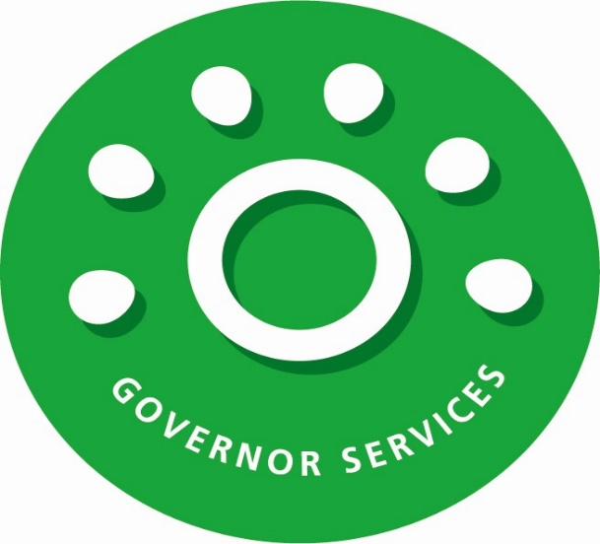
2022-2023 SLA offer for
Southwark Governor Services
and
Governor Training and Development

Quality Support for Excellent Governance – Working in Partnership
Southwark Governor Services provide a comprehensive support and development service for governors and trustees across the borough. We remain an integral part of the Education Learning and Achievement Team and work closely with School Improvement Advisors and Schools HR to support governors in their vital school improvement work.

There are two strands to our offer which are purchased through separate SLA’s
Clerking, Support and Advice
Governor Training and Development

Clerking, Support and Advice – Service Level Agreement

Key benefits of using the service
- A professional, reliable and knowledgeable Clerk (Governance Professional).
- Advice on statutory obligations.
- Up to date information, keeping governors informed of key changes in regulations.
- Advice and support with changes in governance structure.
- Enabling partnerships and mutual support between Boards.
- Support with governor recruitment.
- Access to the full range of functions offered by GovernorHub.
- Discounted access to The Key for Governors for your Board. *New Feature*

The Governor Services Team
- The Governor Services Team is led by the Head of Governor Services who supports Governor Development Advisors and can provide guidance and support to any Board that requires it.
- Governor Development Advisors are skilled professionals, and provide comprehensive and holistic support to Governing and Trust Boards.
- The team undertakes regular training and briefings and is committed to ensuring that knowledge of governance regulations, procedures and requirements are up to date.
- Governor Services are part of the Education, Learning and Achievement Team and our service helps support collaborative working across the whole team.

High quality advice and support
- The Governor Services team provide advice, guidance and support in all areas of governance including (but not limited to):
  - Statutory obligations
  - Website compliance
  - Changes in guidance
  - Areas for development
  - Governor recruitment
  - Governor Induction
  - Federating
  - Complaints
  - Grievances
  - Panels
  - Governor Elections
  - Policy Review

- The team are available via e-mail and telephone during term time, throughout the school year. Outside of this time, the Head of Governor Services will be available or a member of the wider Education, Learning and Achievement Team.
- A wide range of information and news is provided via GovernorHub and the Southwark Schools Website, including model policies, procedures and templates.

Support for effective meetings
- An allocated Governor Development Advisor will attend to clerk and provide advice at all of the meetings that you have bought into. This service includes:
  - a draft agenda based on a model carefully drawn up to ensure that you meet all of your statutory duties and are kept abreast of developments in governance and changes to legislation, tailored to meet your individual requirements and which flags up any action needed. This is sent to the Chair (or committee Chair) and Headteacher at least two weeks prior to the meeting to allow them to discuss and customise.
  - Documents will be collated and made available to governors to meet the statutory deadline of seven clear days before a meeting (subject to being received seven days prior).
  - Information reports that can be provided from GovernorHub including:
    - Governing body membership and vacancies;
    - Governing body meeting attendance;
    - Training attendance
    - Committee membership and link governors;
    - Policy schedule.
- Advice and guidance during your meeting.
- Minutes will be drafted and sent to the Chair (or committee Chair) and Headteacher within ten school days of a meeting.
- They will be available to governors as soon as possible following the receipt of any comments.
- They will include a clear record of all of the governing body decisions and actions, minutes will reflect the support and challenge offered to Senior Leaders, to provide evidence to Ofsted that the governing body is fulfilling this function.
- An annual timetable of dates and times for future meetings will be agreed with Headteachers and Chairs. Although the service will always try to accommodate changes in meeting dates, the expectation is that set dates are adhered to.

Governance Development
- Governor Development Advisors will work closely with the Chair of Governors and Headteacher to support the development of the Governing Body and promote good governance. Areas of support will include (but are not limited to):
  - Meeting newly appointed Chairs and Headteachers
  - Support with undertaking governing board skills audit.
  - Resources and support for undertaking governance self-evaluation.
  - Guidance on link governor visits.
  - Advice on governance structure and constitution.
  - Regular communications with information, guidance, news and updated policies.

Latest features
- All schools continue to receive access to the GovernorHub database as part of the Local Authorities statutory support for school governance.
- Schools that purchase the clerking SLA will automatically be upgraded to full access of GovernorHub, supporting secure document storage and reporting. Schools that do not purchase the clerking SLA are able to upgrade at a discounted price.
- This year, the Local Authority are pleased to be able to offer The Key Governance at a reduced price. This comes as an ‘add on’ to GovernorHub, making access simple for the whole board.

Pricing
- There has been a small price increase of £50 per core meeting package and £50 per additional FGB and committee meeting.
- Additional meetings such as EFGB’s and HR panels have been increased slightly to reflect their increasing complexity.

Next Steps
Whether you are continuing with the clerking service or signing up for the first time, you will need provide details of all the services that you wish to purchase by e-mail to donna-marie.muir@southwark.gov.uk.

In order to ensure you benefit from the full range of services we offer we need a response from you by the end of the summer term. If you wish to reduce or withdraw from the service you must give a full term’s notice.

You are reminded that the decision to change the clerking service you are using rests with the Governing Body.

We look forward to our continuing working partnership in the year ahead.

Donna Muir
Head of Governor Services
Southwark Education, Learning and Achievement
Governors Services

Mobile: 07729 601354
Website: Southwark Schools Website Address

Governor Training and Development Service Level Agreement

As part of the school’s leadership and management team, governors require a range of skills and qualities in order to carry out their roles effectively. Each governing board’s continued professional development is an integral part of a school’s effectiveness and growth. It is therefore essential that governors have access to high quality guidance, information and training and development opportunities.
Our SLA offers a diverse range of relevant courses to help governors effectively fulfil their duties and fully engage in the key areas of school improvement and strategic leadership. Our service has been working in partnership with schools for over 25 years to develop and support school improvement with creative and effective governance practice.
The training and development programme is open to governors from any school, including maintained, academy and free schools. It offers a broad spectrum of courses, briefings and events which are led by high calibre, experienced governance practitioners, both from the local authority and independent providers. The content of the programme is updated regularly to reflect changing legislation, local and national developments and initiatives and can be modified to meet the specific needs of an individual governing body on request.

Feedback received through a regular quality survey indicates that the training and development service is highly valued by governors and schools.

Key features
- A comprehensive annual programme of training courses and events for school and academy governors and trustees covering a wide range of governance and educational matters.
- A programme of induction modules offering a complete introduction to governance.
- Unlimited access to all centrally run courses and events – 15 to 20 sessions each term - for all members of your governing body.
- A bespoke whole governing body training session on a topic chosen by the governing body.
This service includes

- Training and development sessions delivered by experienced trainers and facilitators with the relevant subject knowledge.
- Regular electronic programme updates on courses on offer.
- Telephone and email support and advice on governance training and development.
- Electronic copies of presentations and training materials to share with your governing body.
- Provision of training and development records for each governor to facilitate skills audits and governance reviews.
- Certificates of attendance can be provided upon request.
- Regular evaluation of training and development to ensure that delivery objectives have been met and to quality assure the provision.

General performance standards
We aim to deliver excellence in the services we provide and will work closely with schools to ensure we are supporting you in the most appropriate and effective way.
We undertake a regular customer satisfaction survey (in collaboration with the clerking service, usually every 12 to 18 months) and welcome your views and suggestions about the service. Governors have an opportunity to provide their feedback and comments at the end of each training event through the session feedback form.

Pricing structure
There has been a small price increase of £50 per SLA which is below the current inflation rate.

The cost of the service for schools in hard federations and MATs will be given on application.

Governors in schools not buying into the SLA may still access any part of the training and development programme on a pay-as-you-go basis. The cost to the school will be as follows:
Governor induction programme - £75 per governor per module (£80 academies)
All other courses on the programme - £90 per governor per course (£95 academies)

Cancellations
Schools subscribing to the SLA will be charged a reduced cancellation fee of £35 per place for non-attendance or cancellation of any sessions within 3 working days of the session date. The fee may be waived in exceptional circumstances. Non-subscribing schools will be charged the full cost of the session (£75/90 or £80/95). This is to cover the costs incurred on your behalf with regard to course administration.
Next Steps

The service is provided on the basis of an annual Service Level Agreement. It covers the period from 1 April 2022 to 31 March 2023. To ensure the full benefits that your school and governing board can get from the SLA please complete the corresponding Microsoft form and return to ela.cleary@southwark.gov.uk by the end of the summer term.
We look forward to continue working with your governing board in the year ahead.
Ela Cleary
Governor Training Co-ordinator
Southwark Education, Learning and Achievement

T: 020 7525 5107
E: ela.cleary@southwark.gov.uk
Website: Southwark Schools Website Address

