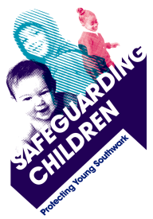
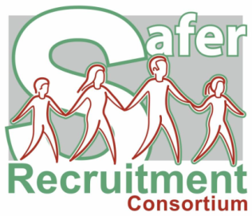
SOUTHWARK CHILDREN’S AND ADULTS’ SERVICES

SAFER RECRUITMENT TRAINING FOR HEADTEACHERS, SCHOOL LEADERS AND SCHOOL GOVERNORS WITH RESPONSIBILITY FOR STAFF RECRUITMENT

Available as two options:
In person at Tooley Street (all day 9am – 4pm) or
Virtual via Zoom (two half-days from 10am – 2pm)

By the end of the course, participants will:
- Understand the key issues of child abuse and the principles of safer recruitment
- Develop an awareness of offender behaviours
- Identify key features of safer recruitment that prevent the appointment of unsuitable people
- Consider policies and practices that minimise opportunities for abuse and ensure prompt reporting of concerns
- Be encouraged and equipped to review their policies and procedures to ensure their effectiveness

Charges:
 | Virtual (two ½ days) | In person (1 day)
Schools buying into the core HR service | £110 | £140
Schools not buying into the core HR service | £150 | £190

All trainers have been accredited to deliver this training by and on behalf of the Safer Recruitment Consortium. Attendance at both sessions is required in order to receive certification.

Dates requested
Name of delegate(s)
School
Position(s)
Telephone number
Delegate email address*
Please advise us of any special requirements to enable delegates to attend or fully participate in this workshop:

Signed (headteacher)
*Certificates will be emailed directly to delegates after the training

To book your place, please fill in your details above and return to: schoolshr@southwark.gov.uk.

