The Federation of St James the Great and St John’s Catholic Primary Schools
St Elmo’s Road, Rotherhithe, London, SE16 6SD.
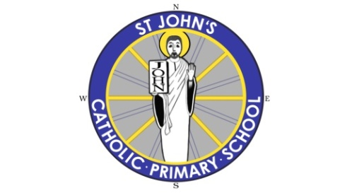
"To Love and Serve One Another"

Part Time Premises Officer Required
Two days per week, salary on request

We’re currently looking for an enthusiastic Premises Officer to work part-time at St. John’s to ensure the smooth running and maintenance of the School Site.
We are looking for an efficient and motivated Individual; You will be working collaboratively with the school's Assistant Premises Officer, the Office Manager and the Executive Headteacher.
Role and responsibilities include:
• Ensuring all school buildings and grounds are cleaned to agreed standards and specifications.
• Ensuring maintenance of all school buildings, grounds and utilities, operating an agreed programme of planned
preventative maintenance and making sure that any repairs are properly and promptly carried out.
• Keeping all school buildings and grounds secure, reporting breaches of security and ensuring that any resultant
damage is repaired or fault rectified properly and promptly.
• Undertaking various porterage, administrative and letting duties.
• Performing all post duties in compliance of relevant health and safety regulations and codes of practice and with due
regard for the health, safety and welfare of all premises users and visitors including contractors.
• Ensuring that the grounds are maintained to a high standard by arranging grass cutting/shrub and tree pruning.

Skills/Experience Required:
• Basic training in one or more of the following: plumbing, general and ground maintenance, electrical/building
maintenance.
• Successful DIY experience.
• Knowledge of Health and Safety regulations.
• Ability to drive and have own transport (desirable).
• Knowledge of record keeping.
• Able to work as part of a team but also independently

As a Federation we are fully committed to safeguarding and promoting the welfare of children and expect all staff and volunteers to share this commitment. All offers of employment are subject to an Enhanced DBS check.

To discuss this vacancy further or to make arrangements to visit the school. Please send an email to office@st-john.southwark.sch.uk and mark the email with ‘vacancy’ in the subject line.
Closing date Midday Friday 14th April
Interviews to be held week beginning Monday 24th April

